What is Playing Out?
Street play, or ‘playing out’, sessions are short, resident-led road closures to let children play safely and freely outside their own front door. Streets are now doing this all over the UK and it’s having really positive benefits for children and communities.

How does it happen?
Neighbours discuss the idea first and then apply to their local council, consulting with everybody living in the street.
Some streets apply to hold a one-off session. Others do it weekly or monthly if their council allows. Sessions usually last between one and three hours.
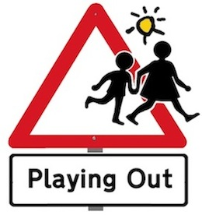
On the day, neighbours close the road to traffic using official signs and barriers. Residents can still drive in and out at walking speed, guided by volunteer stewards.
Parents and carers are responsible for their children as on any other day.

Street play…
- Gives children the space and freedom they need to be healthy and happy
- Helps them gain skills, independence and responsibility
- Lets everyone make friends on the street
- Makes use of the space outside our front doors

‘There’s quite buzz in the street this evening. I know two more people than I did yesterday.’

‘This is great. My son got this bike for this birthday, but the only time he rides it is when I take him to the bike trail in the car – it’s too dangerous here normally.’

‘I love how Playing Out has brought our street together as a friendly, happy place to live!’
Playing Out is a non-profit organisation supporting resident-led street play across the UK.

hello@playingout.net
0117 9537167

www.playingout.net

© Playing Out CIC 2010-2018

