[Your Street] invites you to…

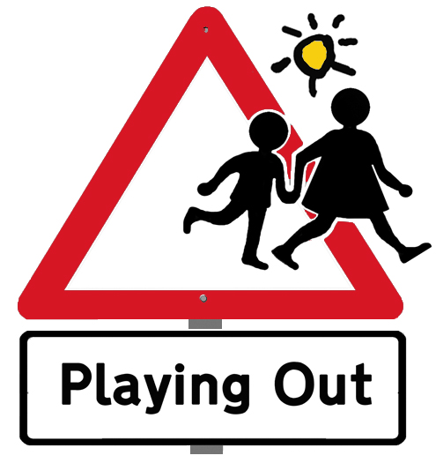
[Day
& Date]

Street open for play
[time]

Please turn over for future dates

Come out to play or just have a cup of tea!

The road will be closed to through traffic, although parked cars can be left on the street and there will be stewarded access for residents. Parents will be responsible for their children.
For more information about the project visit:
www.playingout.net
[Your Street] invites you to…

[Day
& Date]

Street open for play
[time]

Please turn over for future dates

Come out to play or just have a cup of tea!

The road will be closed to through traffic, although parked cars can be left on the street and there will be stewarded access for residents. Parents will be responsible for their children.
For more information about the project visit:
www.playingout.net

Dear neighbours,

Our street has been given (e.g. a Temporary Play Street Order). This means that during certain limited hours the road will be closed to through traffic using ‘road closed’ barriers and volunteer stewards in hi-viz vests. Parked cars can be left on the street and residents and visitors can drive in and out at walking speed, escorted by a volunteer steward. Drivers will be fully responsible for ensuring they drive safely and carefully. Parents will be fully responsible for their own children.

The (e.g. TPSO) will be in effect from (INSERT TIME) until (INSERT TIME) on the following dates:

DAY | DATE
DAY | DATE
DAY | DATE

Please let me know if you have any queries, concerns or ideas. Stewards are really important in making Playing Out sessions work, so if you are happy to help out for half an hour or so, please let me know.

Best wishes, (insert name and contact details)

Dear neighbours,

Our street has been given (e.g. a Temporary Play Street Order). This means that during certain limited hours the road will be closed to through traffic using ‘road closed’ barriers and volunteer stewards in hi-viz vests. Parked cars can be left on the street and residents and visitors can drive in and out at walking speed, escorted by a volunteer steward. Drivers will be fully responsible for ensuring they drive safely and carefully. Parents will be fully responsible for their own children.

The (e.g. TPSO) will be in effect from (INSERT TIME) until (INSERT TIME) on the following dates:

DAY | DATE
DAY | DATE
DAY | DATE

Please let me know if you have any queries, concerns or ideas. Stewards are really important in making Playing Out sessions work, so if you are happy to help out for half an hour or so, please let me know.

Best wishes, (insert name and contact details)

