Risk assessment for playing out street play sessions

Street name:

Date:

Named organiser(s):

(N.B. This is a draft to be adapted by each street – categories and actions are only given as examples).

General benefits of street play sessions:
- Getting residents and families active in their own streets and working together
- Improving the health and wellbeing of children and their families
- Reducing social isolation for older people
- Developing more cohesive and joined up neighbourhoods
- Supporting the Councils’ reputation (as an enabler for community action) in local communities.

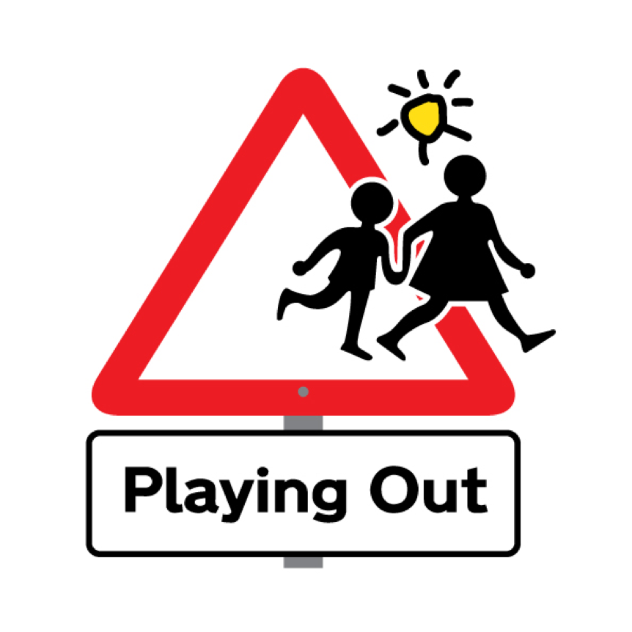 | www.playingout.net  0117 9537167  hello@playingout.net  © Playing Out CIC 2010-2018 |  | www.playwales.org.uk  020 2048 6050  mail@playwales.org.uk

Hazard | Risks | Actions to reduce risk
Moving vehicles and cyclists | Injury to volunteers when setting up road closure, or to children when playing | - Parents to be clearly informed they are still responsible for children’s safety  - All volunteers to wear high visibility jackets  - Road closure points to be clearly marked with traffic cones and appropriate signage  - Road closure notices and door to door leafleting prior to event to warn neighbours in advance of the road closure  - Children to be asked to stay out of the road until all road closure points in place  - Volunteers to alert each other and ensure there are no children in the road if a vehicle needs to pass through the road closure, before removing the barrier  - Cars passing through the barrier to access their property to be slowly led to a parking spot by a steward  - Full steward briefing by event organisers to cover every point of the risk assessment  - Plan how to ensure children know that the session has ended and the street is ‘live’ to cars again. (It can be a good idea to take children inside their houses.)
Children going beyond the barriers

Parked cars | Damage to cars from scooters etc.  Children not being seen by moving bikes/cars
Passing members of the public
Angry drivers

Rubbish in the road

Rain / heat / ice
Anything particular about your street? Steep hill / street off busy main road…?

